**Business Canvas Model Exercise**

1. Working as a group, select a specific RDM service that you will flesh out through the Business Canvas Model approach.

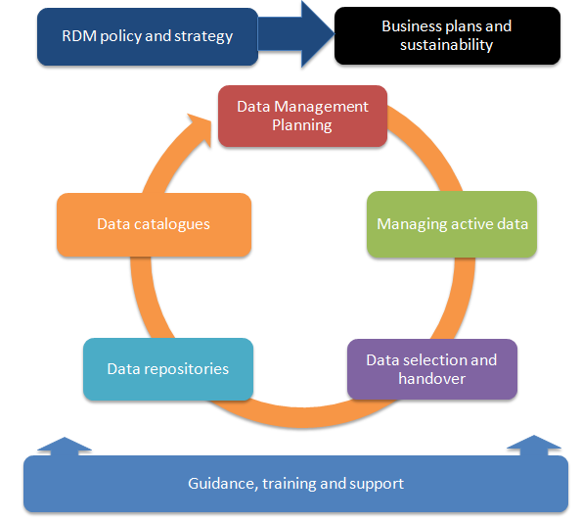

* data management planning support
* implementing platforms for managing and sharing active data
* implementing an institutional data repository
* data selection and handover services (data cleaning, quality, description)
* setting up and maintaining a research data catalogue
* training for early career researchers and/or PhD students

2) Work through the sections of the BCM template. Think about your own organisations and experiences. E.g., what resources do you have across the institution? Who are your customers?

3) Each group will have 2-3 minutes to summarise their discussions.